**CODING CHALLENGE – CAREER HUB**

**TASKS:**

**1.Provide a SQL script that initializes the database for the Job Board scenario “CareerHub”.**

create database careerhub;

use careerhub;

show databases;

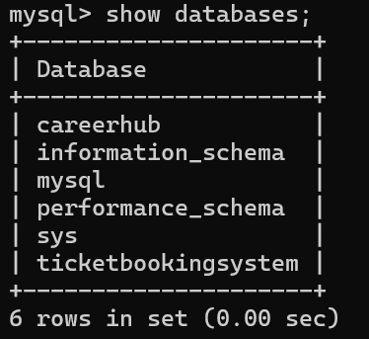

**2.Create tables for Companies, Jobs, Applicants and Applications.**

**Companies**:

create table companies (companyid integer primary key, companyname varchar(50),location varchar(50));

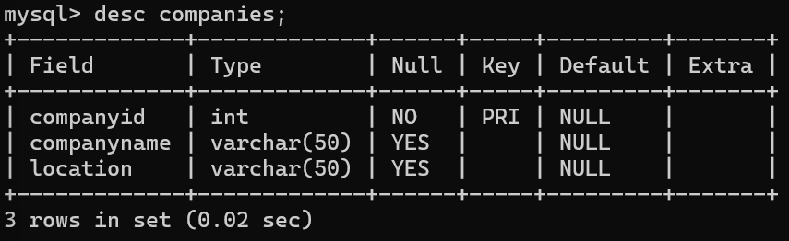

**Jobs**:

create table jobs (jobid integer primary key,companyid integer, jobtitle varchar(50), jobdescription text, joblocation varchar(50), salary decimal(10,2),jobtype varchar(50),posteddate datetime, foreign key (companyid) references companies(companyid));

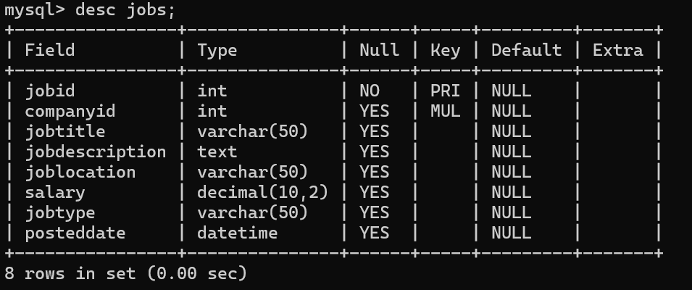

**Applicants**:

create table applicants(applicantid integer primary key,firstname varchar(20),lastname varchar(20),email varchar(50),phone varchar(10), resume text);

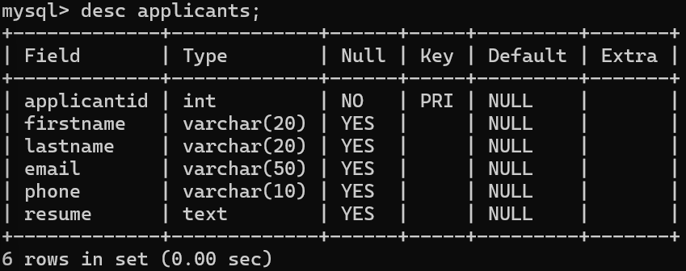

**Applications:**

create table applications(applicationid integer primary key, jobid integer, applicantid integer, applicationdate datetime,coverletter text, foreign key (jobid) references jobs(jobid), foreign key (applicantid) references applicants(applicantid));

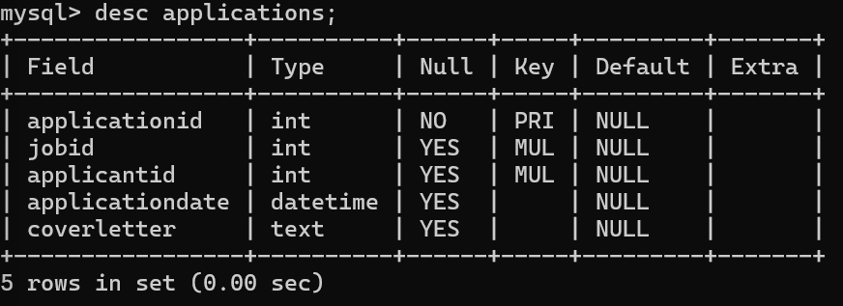

**3.Define appropriate primary keys, foreign keys, and constraints**.

create table jobs (jobid integer primary key,companyid integer, jobtitle varchar(50), jobdescription text, joblocation varchar(50), salary decimal(10,2),jobtype varchar(50),posteddate datetime, foreign key (companyid) references companies(companyid));



create table applications(applicationid integer primary key, jobid integer, applicantid integer, applicationdate datetime,coverletter text, foreign key (jobid) references jobs(jobid), foreign key (applicantid) references applicants(applicantid));



**4.Ensure the script handles potential errors, such as if the database or tables already exist.**

create database careerhub;



**5.Write an SQL query to count the number of applications received for each job listing in the "Jobs" table. Display the job title and the corresponding application count. Ensure that it lists all jobs, even if they have no applications.**

select jobs.jobtitle, count(applications.applicationid) as applicationcount from jobs left join applications on jobs.jobid=applications.jobid group by jobs.jobid;

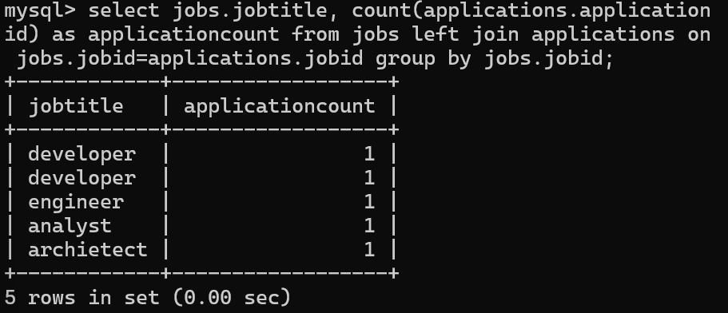

**6.Develop an SQL query that retrieves job listings from the "Jobs" table within a specified salary range. Allow parameters for the minimum and maximum salary values. Display the job title, company name, location, and salary for each matching job.**

select jobs.jobtitle, companies.companyname,companies.location, jobs.salary from jobs join companies on jobs.companyid=companies.companyid where jobs.salary between 45000 and 100000 order by salary;

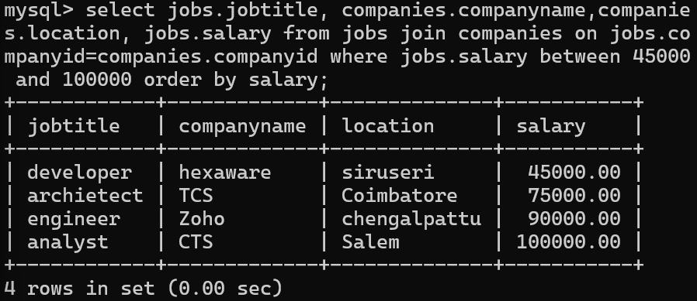

**7.Write an SQL query that retrieves the job application history for a specific applicant. Allow a parameter for the ApplicantID, and return a result set with the job titles, company names, and application dates for all the jobs the applicant has applied to.**

select jobs.jobtitle, companies.companyname, applications.applicationdate from applications join jobs on jobs.jobid=applications.jobid join companies on companies.companyid=jobs.companyid where applications.applicantid=1002;

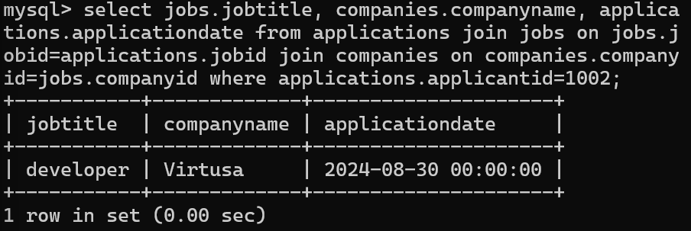

**8.Create an SQL query that calculates and displays the average salary offered by all companies for job listings in the "Jobs" table. Ensure that the query filters out jobs with a salary of zero**.

select companies.companyname, avg(jobs.salary) from companies join jobs on companies.companyid=jobs.companyid where jobs.salary>0 group by companies.companyname;

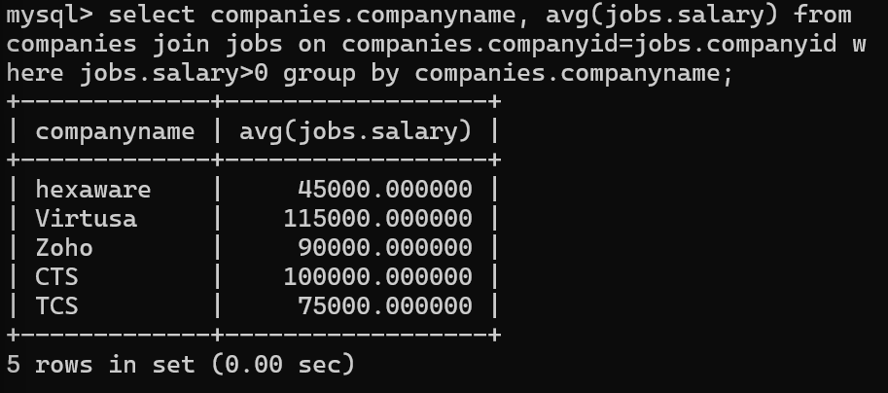

**9.Write an SQL query to identify the company that has posted the most job listings. Display the company name along with the count of job listings they have posted. Handle ties if multiple companies have the same maximum count.**

select companies.companyname, count(jobs.jobid) from companies join jobs on companies.companyid=jobs.companyidgroup by companies.companyid order by count(jobs.jobid)limit 1;

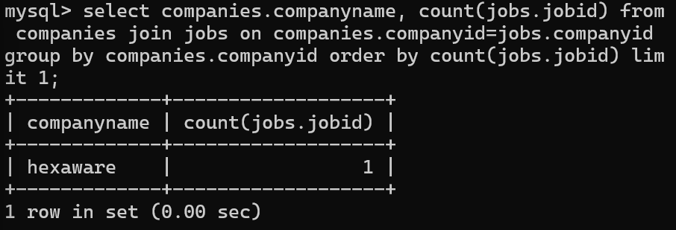

**10.Find the applicants who have applied for positions in companies located in 'CityX' and have at least 3 years of experience**.

**11.Retrieve a list of distinct job titles with salaries between $60,000 and $80,000.**

select distinct jobtitle from jobs where salary between 60000 and 80000;

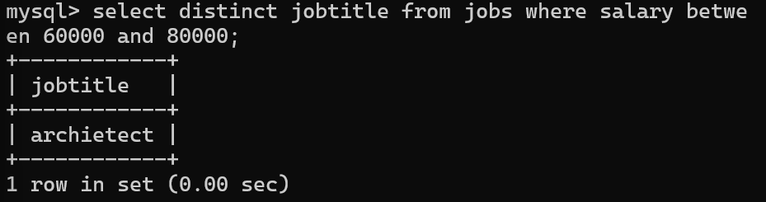

**12.Find the jobs that have not received any applications**.

select jobs.jobtitle from jobs left join applications on jobs.jobid=applications.jobid where applications.applicationid is null;

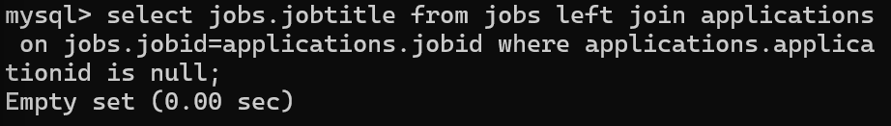

**13.Retrieve a list of job applicants along with the companies they have applied to and the positions they have applied for.**

select applicants.firstname, applicants.lastname, companies.companyname,jobs.jobtitle from applicants left join applications on applications.applicantid=applicants.applicantid left join jobs on applications.jobid=jobs.jobid left join companies on companies.companyid=jobs.companyid;

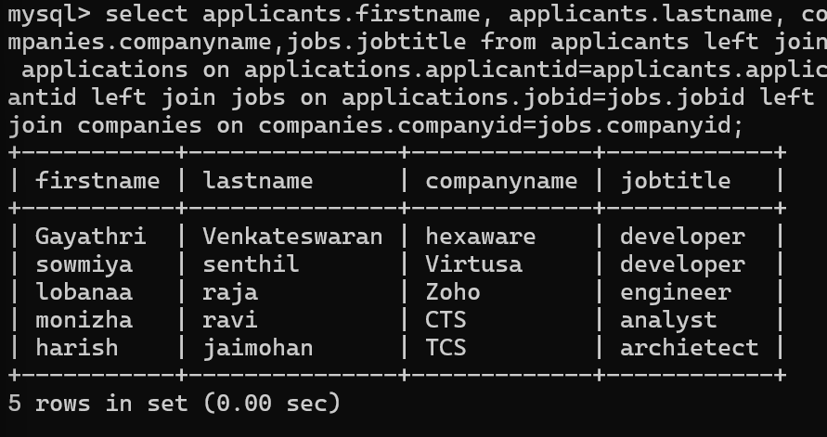

**14.Retrieve a list of companies along with the count of jobs they have posted, even if they have not received any applications.**

select companies.companyname, count(jobs.jobid) as jobcount from companies join jobs on companies.companyid=jobs.companyid group by companies.companyid;

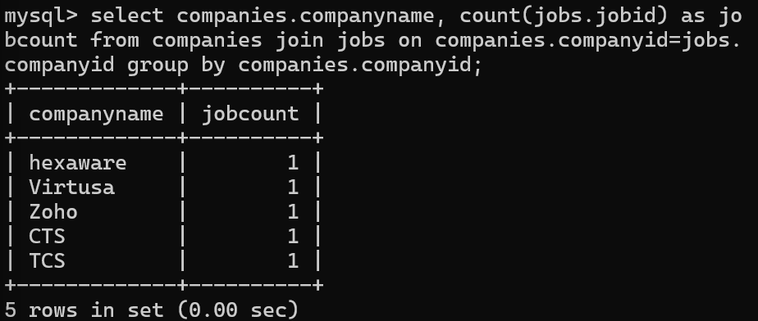

**15.List all applicants along with the companies and positions they have applied for, including those who have not applied.**

select applicants.firstname, applicants.lastname, companies.companyname,jobs.jobtitle from applicants left join applications on applications.applicantid=applicants.applicantid left join jobs on applications.jobid=jobs.jobid left join companies on companies.companyid=jobs.companyid;



**16.Find companies that have posted jobs with a salary higher than the average salary of all jobs**.

select companies.companyname from companies join jobs on companies.companyid=jobs.companyid where jobs.salary>(select avg(salary)from jobs);

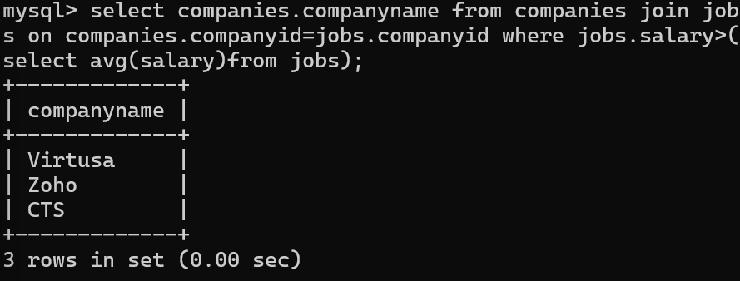

**17.Display a list of applicants with their names and a concatenated string of their city and state**.

select applicants.firstname, applicants.lastname, concat(companies.location) from applicants left join applications on applications.applicantid=applicants.applicantid left join jobs on applications.jobid=jobs.jobid left join companies on companies.companyid=jobs.companyid;

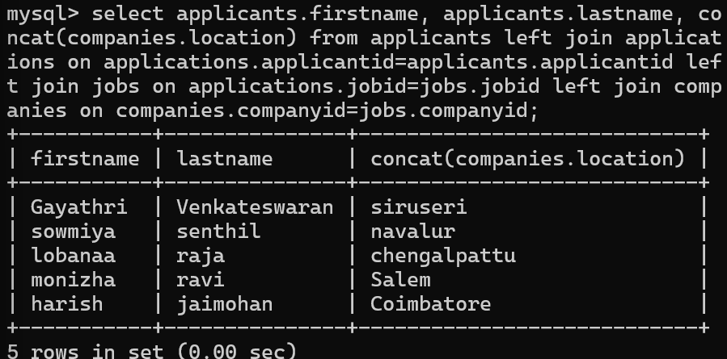

**18.Retrieve a list of jobs with titles containing either 'Developer' or 'Engineer'**.

select jobid,jobtitle from jobs where jobtitle like "%developer%" or jobtitle like "%engineer%";

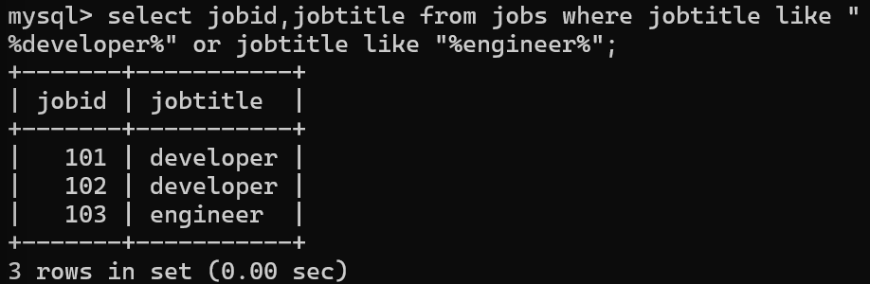

**19.Retrieve a list of applicants and the jobs they have applied for, including those who have not applied and jobs without applicants.**

select applicants.firstname, applicants.lastname, companies.companyname,jobs.jobtitle from applicants left join applications on applications.applicantid=applicants.applicantid left join jobs on applications.jobid=jobs.jobid leftjoin companies on companies.companyid=jobs.companyid;

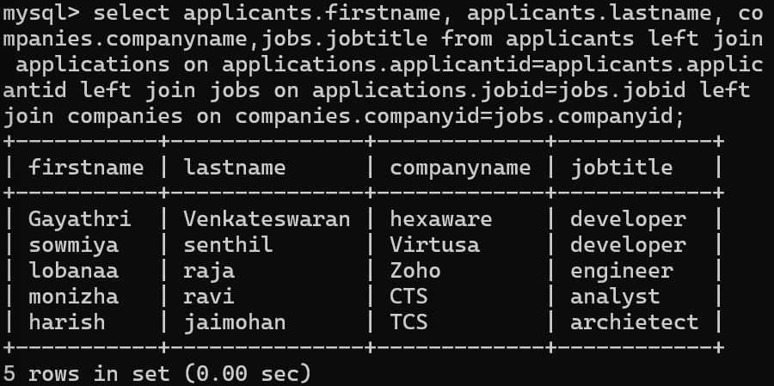

20.**List all combinations of applicants and companies where the company is in a specific city and the applicant has more than 2 years of experience. For example: city=Chennai**